14.4 Tangent Planes

Entry Task: HW Q1–4
Consider z = f(x,y) = 15 – x² – y²
at the point ($x_{0}$, $y_{0}$) = (7,4).
Find/compute the following:

- The corresponding “height”, $z_{0}$.

- The slope in the x-direction.

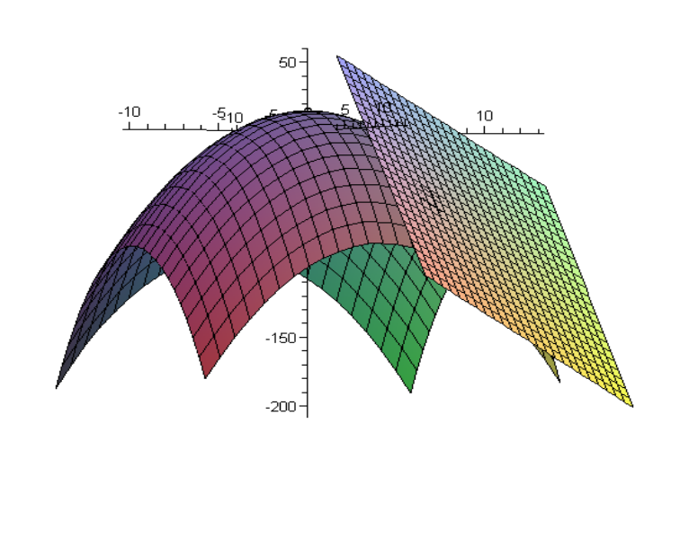

- A tangent vector in the x-direction.

- The tangent line in the x-direction.

The plane that contains all tangent lines to a given surface at a point is given by
$-f_{x}\left(x_{0},y_{0}\right)\left(x-x_{0}\right)-f_{y}\left(x_{0},y_{0}\right)\left(y-y_{0}\right)+\left(z-z_{0}\right)=0$
which we typically write as:
$z-z_{0}=f_{x}\left(x_{0},y_{0}\right)\left(x-x_{0}\right)+f_{y}\left(x_{0},y_{0}\right)\left(y-y_{0}\right)$

Example:
Find the tangent plane for
z = f(x,y) = 15 – x² – y²
at the point (x,y) = (7,4)

Visual: https://www.desmos.com/3d/yprgwmf5ug

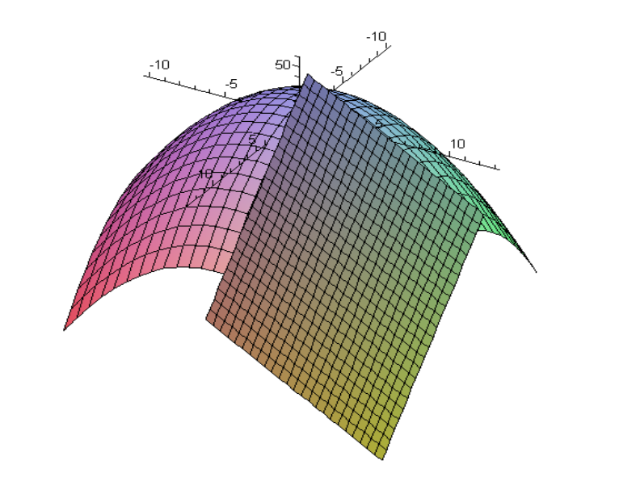

Example Derivation
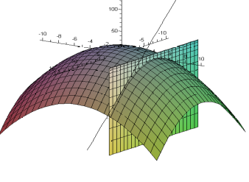
$$f{}_{x}\left(x,y\right)= -2x , f_{x}(7,4) = -14$$

$$f{}_{y}\left(x,y\right)= -2y , f_{y}(7,4) = -8$$

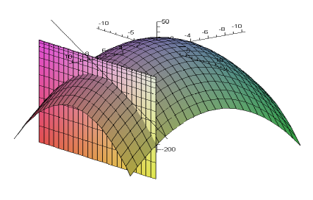

$〈1,0,f_{x}(x_{0},y_{0})〉=$ ‘tangent in x-dir.’$〈0,1,f_{y}(x_{0},y_{0})〉=$ ‘tangent in y-dir.’

Upward pointing normal to the surface
$$〈1,0,f_{x}(x_{0},y_{0})〉×〈0,1,f_{y}(x_{0},y_{0})〉= 〈-f_{x}\left(x_{0},y_{0}\right),-f_{y}\left(x_{0},y_{0}\right),1〉$$

Thus, we can get two vectors that are parallel to the plane:
$$\left\langle 1, 0, f_{x}\left(x_{0},y_{0}\right)\right\rangle =⟨1, 0,-14⟩$$
$$\left\langle 0, 1,f_{y}\left(x_{0},y_{0}\right)\right\rangle =⟨0, 1,-8⟩$$
A normal vector is given by
$$\left\langle 1, 0,-14\right\rangle ×\left\langle 0, 1,-8\right\rangle =⟨14, 8,1⟩$$

Tangent Plane:
$$14(x-7) + 8(y-4) + (z+50) = 0$$

Example: Tangent Planes on a Donut
Consider the torus (donut-shaped surface)
$${\left(\sqrt{x^{2}+y^{2}}-2\right)}^{2}+z^{2}=1$$
The points $P(2,0,1)$and $Q\left(2+\frac{\sqrt{2}}{2},0,\frac{\sqrt{2}}{2}\right)$ are on this torus (why?).

Find the tangent planes at these points.

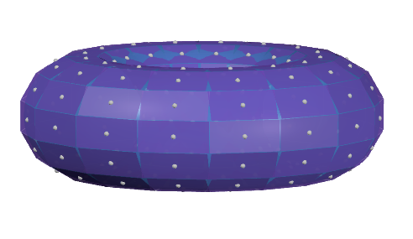

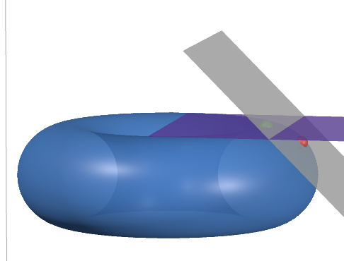

https://www.desmos.com/3d/ekg8pmmhw0

An Application of the Tangent Plane
Linear Approximation HW Q5–6
“Near” the point (x₀,y₀) the tangent plane and surface z-values are close.
$z-z_{0}=f_{x}\left(x_{0},y_{0}\right)\left(x-x_{0}\right)+f_{y}\left(x_{0},y_{0}\right)\left(y-y_{0}\right)$,
which is the same as
$L\left(x,y\right)=z=z_{0}+f_{x}\left(x_{0},y_{0}\right)\left(x-x_{0}\right)+f_{y}\left(x_{0},y_{0}\right)\left(y-y_{0}\right)$
Idea:
$$f\left(x,y\right)≈L\left(x,y\right) for \left(x,y\right)≈\left(x_{0},y_{0}\right)$$

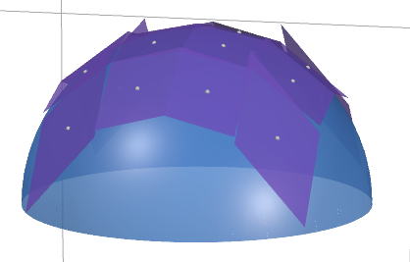

https://www.desmos.com/3d/hj4zzyphnj

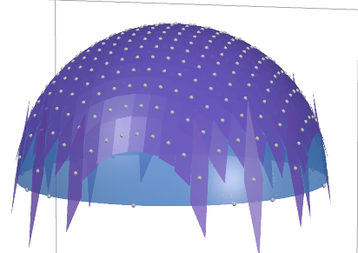

Example: Building Solid Cylinders
A company builds solid circular cylinders with radius 2 meters and height 10 meters.
The formula for the total surface area of a cylinder is $S\left(r,h\right)=2πr^{2}+2πrh$
- Find the tangent plane for $S\left(r,h\right)$ at $(r,h) = (2,10)$.

- A collection of cylinders come off the assembly line with slight errors in manufacturing leading to a radius 2.1 meters and height 9.8 meters.

Numerical References
$$S\left(2,10\right)=2π{(2)}^{2}+2π\left(2\right)\left(10\right)=48π$$
$$S\left(2.1,9.8\right)=2π{(2.1)}^{2}+2π\left(2.1\right)\left(9.8\right)=49.98π$$

$$L\left(2,10\right)=48π+28π\left(0.1\right)+4π\left(-0.2\right)=50π$$

